# Story ID: 03 Admin page

1.       Test scenario: User logged in as administrator and has the ability to access the following from the Utils page:

·         View Profile

·         Create new property

·         Assign tenant/employee/owner to a property

·         Add new employee

·         Edit existing employee

·         Add new owner

·        Edit existing owner

·        Any current property assigned to me

**Expected outcome:** Able to go to any of these pages via clicking the links

**Outcome:**  No failed results and every link can be selected

**Selenium Automation Test file:**  admin_Utils.html

**Selenium Automation result message:** [info] Test case passed

2.       Test scenario: User logged in as Tenant and cannot access the Utils page.

**Expected outcome:**  User logs in successfully and cannot select the Utils link in the menu. Test Should fail.

**Outcome:** Test failed (expected outcome)

**Selenium Automation Test file:**  tenant_Utils.html

**Selenium Automation result message:** [info] Test case failed

3.       **Test scenario**: User logged in as an employee and has the ability to access the following:

·         View Profile

·         Create new property

·         Add new owner

·        Edit existing owner

·    Any current property assigned to me

**Expected outcome:**  They should only be able to access the above links any other links should fail

**Outcome:** Successful on view profile, create new property, Edit existing owner. Fails on anything else

**Selenium Automation Test file:**  employee_Utils.html

**Selenium Automation result message:**   
View profile: [info] Test case passed

Create new property : [info] Test case passed

Add new owner: [info] Test case passed

 Assign tenant/employee/owner to a property

Add new employee: [info] Test case failed

Edit existing employee: [info] Test case failed

Add new owner: [info] Test case failed

Edit existing owner: [info] Test case failed

 Any current property assigned to me: [info] Test case failed

4.       **Test scenario**: User logged in as an owner and has the ability to access the following:

·         View Profile

·         Create new property

**Expected outcome:** Should be able to access the above links and fail on anything else.

**Outcome:** Successfully accessed view profile and create new property

**Selenium Automation Test file:**  employee_Utils.html

**Selenium Automation result message:**

View profile: [info] Test case passed

Create new property : [info] Test case passed

Add new owner: [info] Test case failed

 Assign tenant/employee/owner to a property

Add new employee: [info] Test case failed

Edit existing employee: [info] Test case failed

Add new owner: [info] Test case failed

Edit existing owner: [info] Test case failed

 Any current property assigned to me: [info] Test case failed

# Story ID: 09 Assign properties

1.       Test scenario: User logged in as administrator and has the ability to assign a tenant to a property. The user can then unassign the tenant and tenant will appear again in the unassigned drop down box.

**Expected outcome:** User will successfully assign a tenant to a property and view them in the assigned page

**Outcome:**  Successful. User has assigned a tenant to a property

**Selenium Automation Test file:**  assign_tenant.html

**Selenium Automation result message:** [info] Test case passed

2.      **Test scenario:** User logged in as administrator and has the ability to assign a tenant and an owner to a property and then unassign them, which will return the tenant and owner back into the list of unassigned drop down boxes.

**Expected outcome:**  User will successfully assign a tenant and an owner to a property, which will display on the assigned page. Then once removed will display back into the unassigned page.

**Outcome:** Successful. The owner and tenant appear on the assigned page. Then once removed will display back on the unassigned page.

**Selenium Automation Test file:**  assign_owner.html

**Selenium Automation result message:** [info] Test case passed

3.       **Test scenario:** User logged in as administrator and has the ability to assign a tenant and an employee to a property and then unassign them, which will return all the users back into the list of unassigned drop down boxes.

**Expected outcome:**  User will successfully assign a tenant and employee to a property, which will display on the assigned page. Then once removed will display back into the unassigned page.

**Outcome:** Successful. The owner and employee appear on the assigned page. Then once removed will display back on the unassigned page.

**Selenium Automation Test file:**  assign_owner.html

**Selenium Automation result message:** [info] Test case passed

4.      **Test scenario:** User should assign in as administrator and try to assign an employee and owner without assigning a tenant. They then should be able to assign all 3 tenants, employees and owners. This should be followed by successfully unassigning the tenant, which should leave the employee and owner still assigned to that page.

**Expected outcome:**  If a tenant is not unassigned then it should display “you must assign a tenant to a property”. Owners and employees will stay assigned to that property even if they tenant has been removed.

**Outcome:** Successful.

**Selenium Automation Test file:**  assign_all.html

**Selenium Automation result message:** [info] Test case passed

# Story ID: 16 Website Security

1.       Test scenario: User has logged in as tenant and will be forbidden from entering the url for the following pages

·         Create_property.php

·         assign_property.php

·         employees_registration.php

·         employee_profile.php

·         owner_registration.php

·        owner_profile.php

**Expected outcome:** each url should display a “forbidden” message and redirect the user

**Outcome:**  The user cannot access the above pages. Successful.

**Selenium Automation Test file:**  security_tenant.php

**Selenium Automation result message:** [info] Test case passed

2.       **Test scenario:** User is logged in an employee and cannot access the following pages by entering in the URL

·         assign_property.php

·         employees_registration.php

However they should be allowed to access the following

·         Create_property.php

·         employee_profile.php

·         owner_registration.php

·        owner_profile.php

**Expected outcome:**  A forbidden message should appear for the assign property and employee_registration pages. The rest should appear.

**Outcome:** Successful.

**Selenium Automation Test file:**  security_employee.html

**Selenium Automation result message:** [info] Test case passed

3.       **Test scenario**: Test scenario: User has logged in as owner and will be forbidden from entering the url for the following pages

·         assign_property.php

·         employees_registration.php

·         employee_profile.php

·         owner_registration.php

However they should be allowed to access the following

·         Create_property.php

·        owner_profile.php

**Expected outcome:**  A forbidden message should appear for the above pages except the create_property and owner_profile.

**Outcome:** Successful.

**Selenium Automation Test file:**  security_owner.html

**Selenium Automation result message:** [info] Test case passed

# Story ID: 23 Staff accounts

**1. Test scenario:** When employee details are edited the change is effective immediately and permanently in the employees details screen.

**Expected outcome:** All relevant information has been updated successfully and is available in the employee details screen.  
**Outcome**: Success

**Selenium Automation Testing file**: Employee_Details_Edit

**Selenium Automation result message:** [info] Test case passed

2. **Test scenario:** Test multiple account types to check they have access to the appropriate features.

**Expected outcome:** Only employees have access to the Utils tool bar, all other user accounts should not even be able to view Utils tool bar.

**Outcome**: Success, passed all tests

**Selenium Automation Testing file**: nouser_access_to_utils

**Selenium Automation result message:** [info] Test case passed

3. **Test scenario**: Attempt to create two employee accounts using the same username.

**Expected outcome:** A username can only be used once to create an employee account.

**Outcome**: Success

**Selenium Automation Testing file**: account_only_created_once

**Selenium Automation result message:** [info] Test case passed

4. **Test scenario**: Use the admin account to create a new employee account and update an existing account.

**Expected outcome:** From the admin account a new employee can be created and edited successfully.

**Outcome**: Success, all tests passed.

**Selenium Automation Testing file**: employee_creation_edit

**Selenium Automation result message:** [info] Test case passed

**Acceptance testing:**

Employee creation:

**Test scenario:** Create a new employee with invalid DOB.

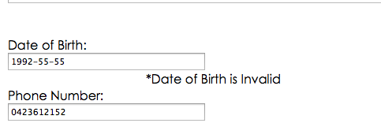

**Outcome**: Success

**Test scenario**: Attempt to create a new employee with empty fields.

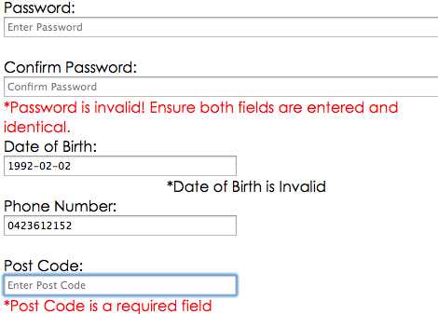

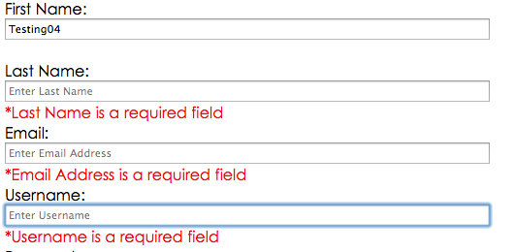

**Outcome**: Success, doesn’t create employee

**Test scenario**: Attempt to edit employee account to have invalid DOB.

Set DOB to invalid date:

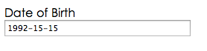

Invalid date is saved successfully:

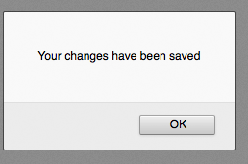

DOB is reset to 0000-00-00:

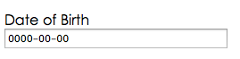

**Outcome**: Semi-success, did not save invalid date. Fix in next release to display error message for invalid dates.

**Test scenario**: Attempt to edit employee details with empty fields.

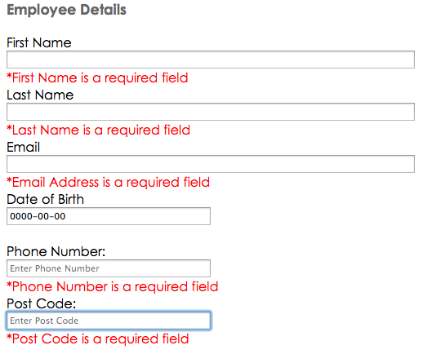

**Outcome**: Success

**Test scenario**: Use new employee account to log in.

Create new employee account:

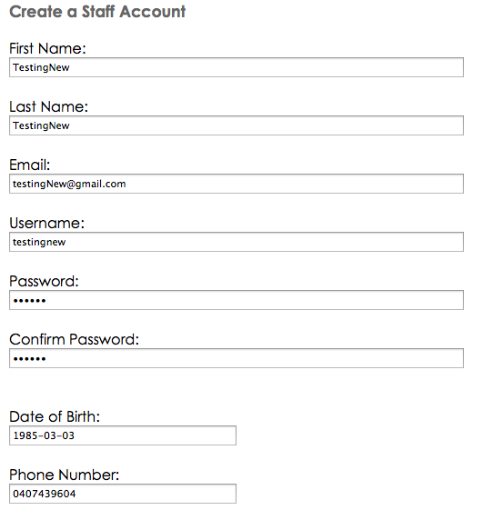

Sign in using new account:

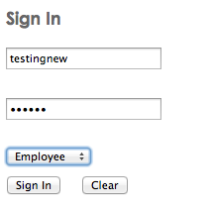

Account sign in successful:

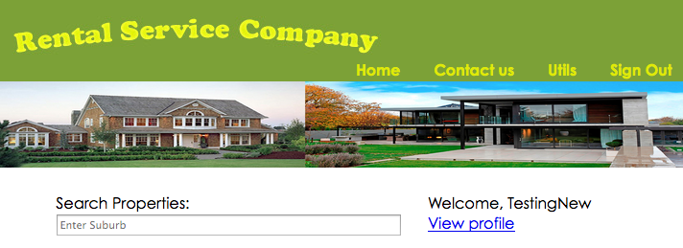

All employee functions available:

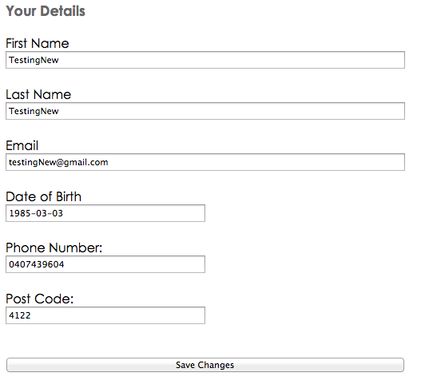

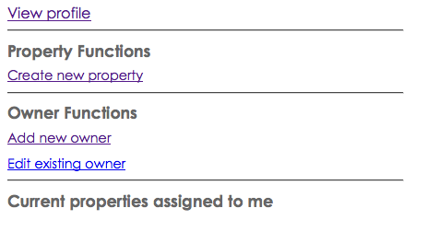

**Outcome**: Success